人民币境内汇款申请书 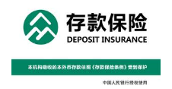
RMB PAYMENT APPLICATION FORM

委托日期Application Date：________年（Y）____月（M）____日（D）

□普通Normal □加急Urgent □次日到账Next Day
付款人资料Account Holder Information
付款人户名Debit Account Name
付款账户Debit Account No.
开户行Debit Account with Bank | Dah Sing Bank (China) Limited, Branch
收款人资料Beneficiary Information
收款人全称Beneficiary Account Name
收款账户Beneficiary Account No.
汇入地点 Place of Remittance
收款行名称Beneficiary Bank Name
付款信息Payment Details
币种及付款金额Currency/Debit Amount
付款金额（大写）Debit Amount in Words
附加信息及用途
Additional Information & Payment Purpose
客户授权 Customer Authorisation | 银行专用栏 For Bank Use Only
此汇款支付给收款人。This remittance is paid to the beneficiary.  汇款人签字Signature | 银行审核意见  经办人Maker：  复核人Checker：  银行盖章Bank Chop：

